**Republika ng Pilipinas Lalawigan ng Bulacan Bayan ng Bulakan**

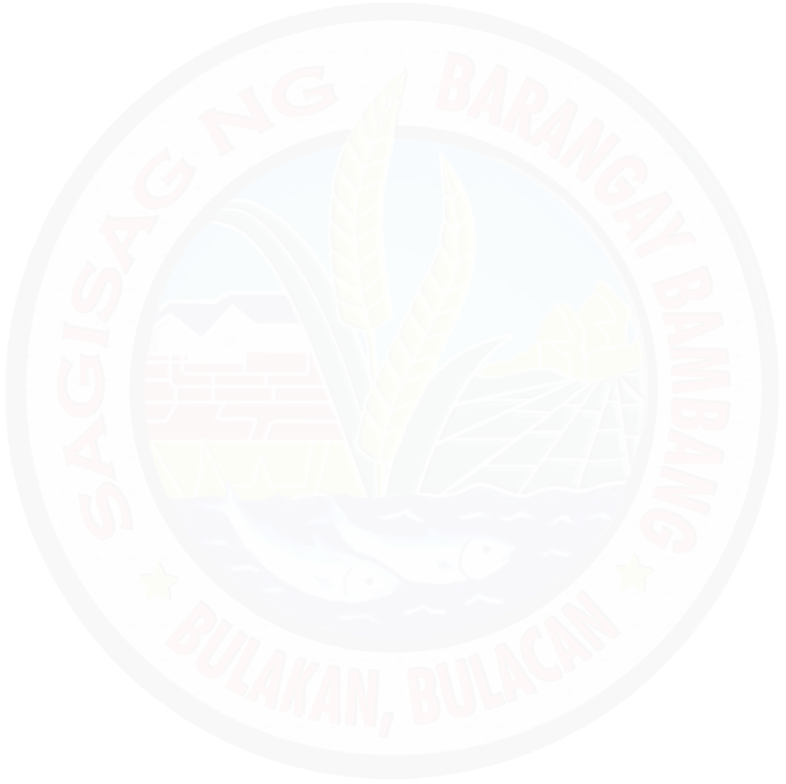

**BARANGAY BAMBANG**

**TANGGAPAN NG PUNONG BARANGAY**

# {date}

Certificate of Residency

# TO WHOM IT MAY CONCERN:

This is to certify that, **{name}** a bonafide resident of Purok {purokNumber} Barangay Bambang Bulakan, Bulacan.

This certifies further **{name}** been living in this barangay since 2022.

This certification is issued upon the request of **{surname}** for whatever legal intents and purposes it may serve him/her.

Issued this {dayNum} day of {month}, {year} at Barangay Bambang Bulakan, Bulacan.

**CTC No. 27813153**

**Issued on: {dateNum}**

**Issued at Bulakan, Bulacan**

**Resibo blg 4003314**

**Halaga: P{price}.00 Petsa: {dateNum}**



<https://www.facebook.com/MGALAKISABAMBANGBULAKANBULACAN>

# JOSE NARCISO C. ROQUE

**Punong Baranggay**



Purok 1, Bambang, Bulakan, Bulacan 813-1243